38.81: Momentum:
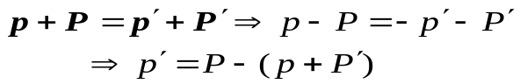
energy: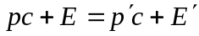
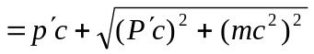
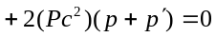
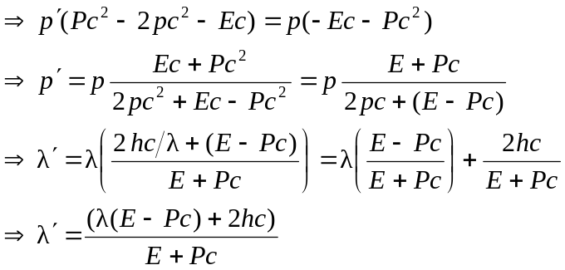
If
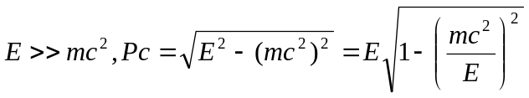
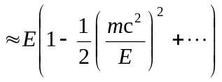
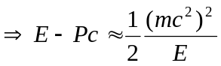
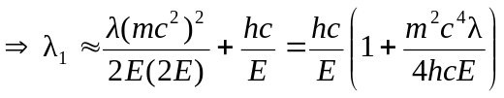
b) If
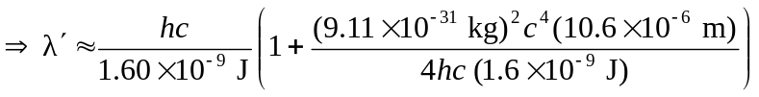

c) These photons are gamma rays. We have taken infrared radiation and converted it into gamma rays! Perhaps useful in nuclear medicine, nuclear spectroscopy, or high energy physics: wherever controlled gamma ray sources might be useful.

